File permissions in Linux

Project description
I am a security professional at a large organization and part of my job is to ensure users on this team are authorized with the appropriate permissions. My task is to examine existing permissions on the file system using linux commands. I need to determine if the permissions match the authorization that should be given, and if they do not match, I need to modify the permissions to authorize the appropriate users and remove any unauthorized access.

Check file and directory details
I must check the permissions set for files and subdirectories in the projects directory.

First, I moved the working directory to the projects directory (cd command) and then displayed the permissions of all files and folders in the current working directory (projects/), including the hidden ones (ls -la command, which list all files and directories with their permissions with the -l option and shows even the hidden directories with the -a option).

The output of my command indicates that there is one directory named drafts, one hidden file named .project_x.txt, and five other project files.
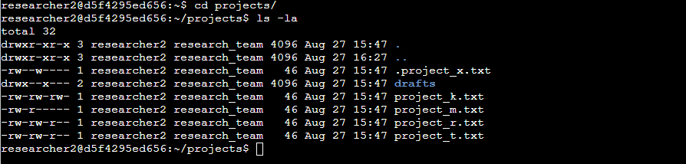

The permissions of all files and folders are:

drwxr-xr-x 3 researcher2 research_team 4096 Aug 27 15:47 .
drwxr-xr-x 3 researcher2 research_team 4096 Aug 27 16:27 ..
-rw--w---- 1 researcher2 research_team 46 Aug 27 15:47 .project_x.txt
drwx--x--- 2 researcher2 research_team 4096 Aug 27 15:47 drafts
-rw-rw-rw- 1 researcher2 research_team 46 Aug 27 15:47 project_k.txt
-rw-r----- 1 researcher2 research_team 46 Aug 27 15:47 project_m.txt
-rw-rw-r-- 1 researcher2 research_team 46 Aug 27 15:47 project_r.txt
-rw-rw-r-- 1 researcher2 research_team 46 Aug 27 15:47 project_t.txt

Each line follows the next pattern:

The 1st character indicates the file type. The d indicates it’s a directory. When this character is a hyphen (-), it's a regular file.
The 2nd-4th characters indicate the read (r), write (w), and execute (x) permissions for the user. When one of these characters is a hyphen (-) instead, it indicates that this permission is not granted to the user.
The 5th-7th characters indicate the read (r), write (w), and execute (x) permissions for the group. When one of these characters is a hyphen (-) instead, it indicates that this permission is not granted for the group.
The 8th-10th characters indicate the read (r), write (w), and execute (x) permissions for the owner type of other. This owner type consists of all other users on the system apart from the user and the group. When one of these characters is a hyphen (-) instead, that indicates that this permission is not granted for other.

The second block of text in the expanded directory listing is the user who owns the file. The third block of text is the group owner of the file. Next blocks refer to file size, date and finally name of the file or folder.

Describe the permissions string
Taking a closer look at one of the previous files—such as the hidden file .project_x.txt—it has the following permissions:

-rw--w----

The first character represents the type of file, in this case is a file, which is represented by a hyphen.

The next three characters reflect the permission of the user who created the file. The first character refers to reading permissions of the owner user, in this case is an r, meaning the user can read the file; the next character refers to writing and editing permissions of the content of the file, in this case is an w, meaning the user can write in the file; and the final character refers to execute permissions to the file, in this case it has a hyphen, meaning the user doesn’t have the execute permission to this file.

This three-character pattern repeats for the next two sets, representing the permissions for the file's group and others (any user who is neither the owner nor a member of the group). In this case, users in the owner's group only have write permission, while other users have no permissions on the file.

Change file permissions
Based on the previous output, I determined whether any files have incorrect permissions and updated them accordingly.

First, the project_k.txt file has write permissions for the owner type of other, so I removed it with the command chmod o-w project_k.txt. After this, I used ls -la to review the updates I made.

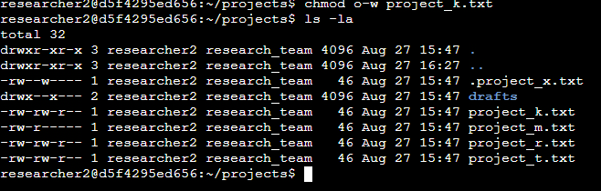

The chmod command requires two arguments. The first argument indicates how to change permissions, and the second argument indicates the file or directory that you want to change permissions for. In this case, it’s necessary to remove writing permissions to other users (first argument: o-w) to the file project_k.txt (second argument).

Next, the file project_m.txt is a restricted file and should not be readable or writable by the group or other; only the user should have these permissions on this file. Using chmod g-r project_m.txt, removes the reading permission to the group, letting the file not readable or writable by the group or other. After this, I used ls -la to review the updates I made.

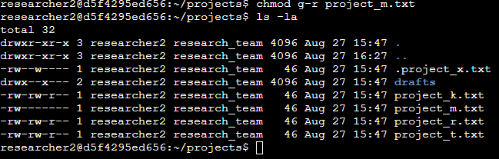

Change file permissions on a hidden file
The hidden file .project_x.txt must not have write permissions for anyone, while both the owner and the group need read access. I know .project_x.txt is a hidden file because it starts with a period (.). Running chmod u-w,g-w+r .project_x.txt removes write permissions for the user and group and adds read permission for the group, leaving the file readable by both.

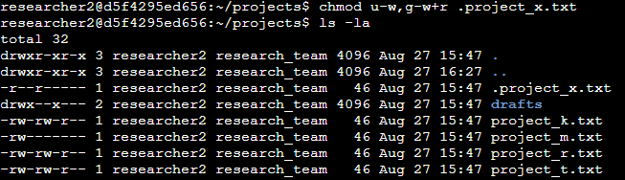

Change directory permissions
The files and directories in the projects directory belong to the researcher2 user. Only researcher2 should be allowed to access the drafts directory and its contents. The group has access permission to the projects directory, so it must be removed running chmod g-x drafts/.
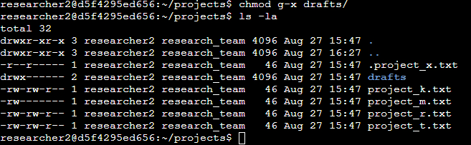

Summary
As a security professional, I audited file and directory permissions in Linux using the ls -la command to detect access-control misconfigurations, and remediated them using chmod.

